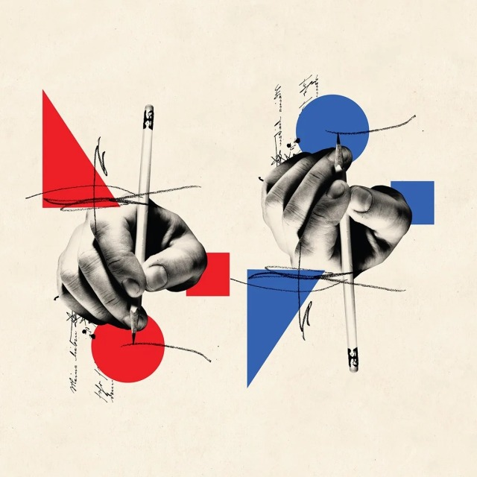
Poster 1
Artist: Cristiana Couceiro
The hands have the highest level of hierarchy, followed by, the shapes in the background, and finally, the writing. The hands are at the highest level because of their size, and the fact that they are put on top of the colored shapes, giving them a little extra contrast. The bright colors of the shapes make them stand out from the rest of the image, however, since they are placed in the background, your eyes go to the hands first. The writing is thin and black which makes it almost fade into the background.
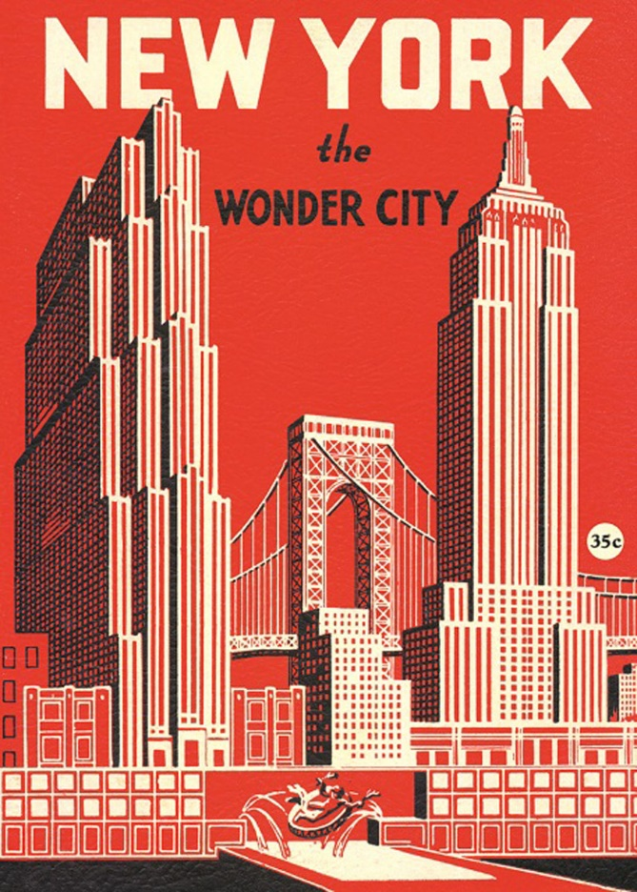
Poster 2
The illustration of the city has the highest place on the hierarchy, followed by the words “New York”, next are the words “wonder city”, and finally, the word “the” is at the lowest level. The city is at the highest level because of its placement, size, and color. It takes up the majority of the work, including the center of the page, which is where most people look first. The light color stands out on the background and by adding darker lines/areas, the artist ensures that you look at the buildings first before moving on to the writing, which uses the same colors, but separately. “New York” is next because while the light color does stand out on the background, the letters are large, and it is centered at the top of the page, it does not have as much contrast as the city. It is further pushed into the background by the fact that part of the buildings overlap a couple of the letters. The darker color of the words “wonder city” stands out less than the lighter colors on the poster, and the typography is smaller than that of the words “New York”. However, since “wonder city” is written in all caps, it stands out more than “the”, which is, not only all lowercase, but also in a slightly smaller font.

